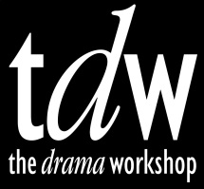
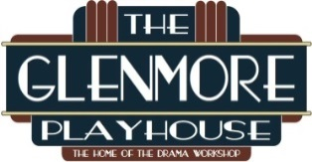
The Drama Workshop
at The Glenmore Playhouse
2015 – 2016 Season
*Subscribe by 7/15/15 to get a bonus Bring-A-Friend ticket to the show of your choice.

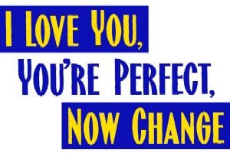
September 11 - 27, 2015 Book and Lyrics by Joe DiPietro, Music by Jimmy Roberts. Directed by Linda Abbott
This musical celebration of the mating game takes on the truths and myths behind that contemporary conundrum known as 'the relationship.’ Act I explores the journey from dating and waiting to love and marriage, while Act II reveals the agonies and triumphs of in-laws and newborns, trips in the family car and pick-up techniques of the geriatric set. This hilarious revue pays tribute to those who have loved and lost, to those who have fallen on their face at the portal of romance, to those who have dared to ask, 'Say, what are you doing Saturday night?' Rated PG-13.

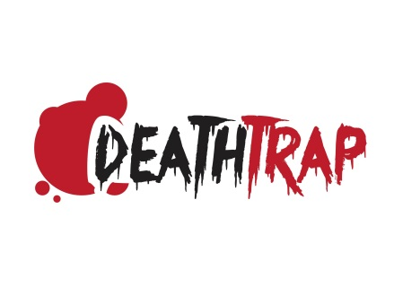
Oct 23 – Nov 8, 2015 by Ira Levin. Directed by Joseph Penno, Jr.
World-famous thriller playwright Sidney Bruhl is suffering from a chronic case of writers' block. When one of his former students shows up at his doorstep with what might be the next Broadway hit, Sidney and his wife concoct a deadly plan to make the manuscript their own. Holding the record for the longest running comedy-thriller on Broadway, Deathtrap is filled with twists and turns in a series of thrilling events that will keep you guessing on the edge of your seat until the very last moment! Rated PG-13.

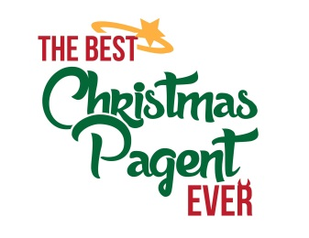
December 4 - 13, 2015 by Barbara Robinson. Directed by Ivory Mazur
When the bullying, cigar-smoking Herdman kids find out that church is followed by free cookies, punch, and other refreshments, they show up in force, just in time to learn about auditions for the upcoming Christmas Pageant. When the Herdmans take key parts in the Pageant and collide with the Christmas story head on; the result will either be the most disastrous Christmas Pageant ever . . . or the best! A wonderful Christmas outing for the entire family.

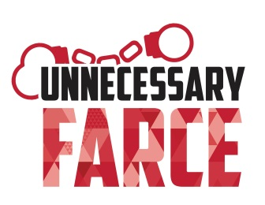
Feb 26 – Mar 13, 2016 by Paul Slade Smith. Directed by Ray Persing

"Two cops. Three crooks. Eight doors. Go." In an economy motel room, an embezzling mayor is supposed to meet with his female accountant. In the room next door, two undercover cops are supposed to catch the meeting on videotape. But there's some confusion as to who's in which room, who's watching the video, who's taken the money, who's hired a hit man, and why the accountant keeps taking off her clothes. Unnecessary Farce is filled with doors slamming, clothes flying, and bagpipes bleating, all of which adds up to an over-the-top tale of mix-ups and mayhem that’s laugh out loud funny from start to finish. Rated PG-13.

Apr 22 – May 8, 2016 Words and music by Harvey Schmidt and Tom Jones.
Directed by Dennis Murphy
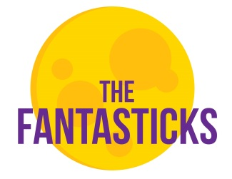
The Fantasticks, by Tom Jones & Harvey Schmidt, is the world's longest running musical – running for over 50 years in Manhattan and entrancing generations of audiences the world over. The Fantasticks is a funny and romantic musical about a boy, a girl, two fathers and a wall. The narrator asks the audience to use their imagination and follow him into a world of moonlight and magic. The boy and the girl fall in love, grow apart, and finally find their way back to each other after realizing the truth in El Gallo's words that "without a hurt, the heart is hollow". The famous score, which includes the classics Try To Remember, They Were You, and Soon It's Gonna Rain, is as timeless as the story itself. Rated PG.

www.thedramaworkshop.org
“Like” The Glenmore Playhouse on Facebook

